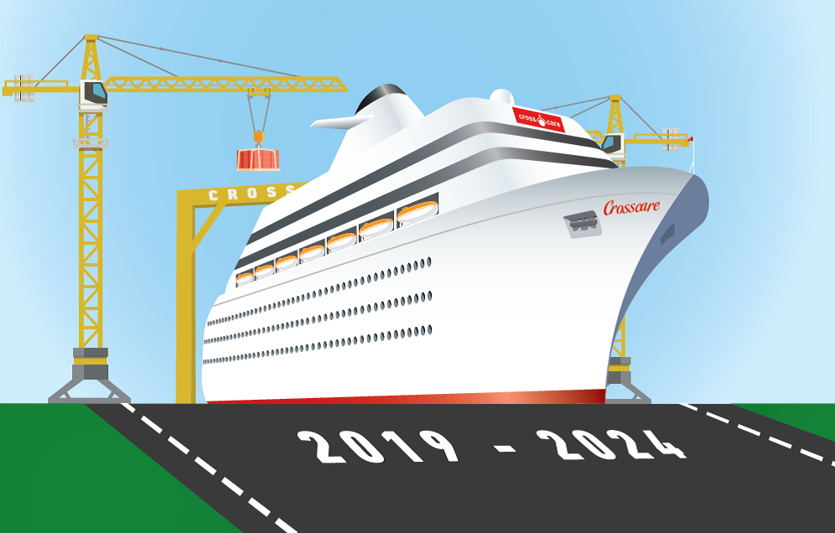

Development Process for Faith to Action Strategy No 3. 2019- 2024
Phase one- Preparation | Who | When
- Meeting with Managers and Crosscare board to plan out full process and sessions | SMT & Managers | June 11th
- Review of the impact of and learning from “Faith to Action 2014-2019”.  Survey to all board members, staff and volunteers individually focusing on the impact of the strategy and its relevance. Surveys to be completed by all and returned by end of August. Analysis of results will be circulated back to all projects in September. | Gordon and Greg | End August
- Strategy process to be launched and widely circulated to include a briefing piece for inclusion in Community College Autumn programme booklet. The gathering event can be used to generate awareness and to gain some feedback from large numbers of service users who will be present. There will be fliers and a video booth to collect ideas and feedback from all at the event. | Conor and Ciara (communications)  Yvonne and Ger | 27th June
Phase two – Inclusive engagement
- Each project commits to having a “Focus on Strategy Week” The outcome of this week is to produce materials / report that summarises the views of the service users, staff and volunteers on:  - The relevance of our Vision, Mission, Values, Ethos and statement of who we serve  - The effectiveness of each project and its challenges and opportunities  - Identification of areas Crosscare needs to focus on for next strategy cycle  Managers to call on their peers to facilitate local sessions. This crossover will allow local managers to contribute to their project sessions and all space for all to contribute. | SMT to drive this in their own areas | Meeting with managers 3rd Sept and all projects to hold week by 2nd week in October  2nd week  October
- Review of external environment in which Crosscare now operates identifying challenges and opportunities for the next five years. This will be undertaken through a series of breakfast meetings during September / October with guest speakers and external input | Niamh and Yvonne  All welcome
- Analysis of role and positioning for social care and youth work within the Archdiocese of Dublin ARCHBISHOP/ DIOCESE /CURIA / DEANERIES | Conor
- Production and circulation of a discussion document based on all of the above. | Conor and Ciara &  Board
Phase three - Developing our plan

- Arrange to meet with key funders to discuss document and ascertain their views | Conor and relevant SMT members | End October
- Arrange major one day conference on “Strategy Development.” This conference will aim to maximise participation from all projects (Staff, vols and service users), board and diocese. Focus will be on cross project sessions on  - Vision mission and values  - Service areas including Homelessness, Youth Work, Young People at risk, Food Poverty, Information and advocacy, social Policy, Mental Health  - New initiatives / ideas  - Identification of key objectives for new strategy | Sinead Tierney, Michael & practice development team and SMT | 24th October  End October
- Develop first draft of new strategy for discussion . | Conor and Ciara with SMT & board | 24th October  End October
- Present final draft to Board of Management | Board | November
- Present new documents for approval, publication and launch. | Archbishop Martin | November

